EXPT NO: 4 | Probabilistic Classification using Naïve Bayes  (Gaussian & Multinomial Naïve Bayes)
DATE: 13.02.2026

PRE-LAB QUESTIONS (PROVIDE BRIEF ANSWERS TO THE FOLLOWING QUESTIONS)
- Why is Naïve Bayes called a probabilistic classifier?
Naïve Bayes is called probabilistic because it uses probability theory, specifically Bayes’ Theorem, to calculate the likelihood that a data point belongs to a particular class based on prior and conditional probabilities.

- What is the “naïve” assumption made by Naïve Bayes?
The “naïve” assumption is that all features are conditionally independent given the class label. It assumes one feature’s presence or value does not affect another when predicting the class.

- How does conditional independence simplify computations?
Conditional independence allows the joint probability of features to be computed as the product of individual probabilities. This reduces complex multivariate calculations into simple multiplications, making the model computationally efficient and scalable.
- What is the role of prior probability in classification?
Prior probability represents the initial belief about how likely each class is before seeing any features. It influences the final prediction by weighting classes according to their overall frequency in the training data.

- Why is Laplace smoothing necessary?
Laplace smoothing prevents zero probabilities when a feature does not appear in a class during training. By adding a small constant, it ensures all probabilities remain non-zero, improving model robustness and generalization.

- How does Naïve Bayes handle high-dimensional data efficiently?
Naïve Bayes handles high-dimensional data efficiently because it treats features independently, avoiding complex covariance calculations. This reduces computational cost and memory usage, making it suitable for text and sparse datasets.

- Difference between Gaussian, Multinomial, and Bernoulli Naïve Bayes?
Gaussian Naïve Bayes assumes features follow a normal distribution. Multinomial Naïve Bayes works with count-based features like word frequencies. Bernoulli Naïve Bayes uses binary features indicating presence or absence of attributes.

- Why is Naïve Bayes often effective for text classification?
Naïve Bayes works well for text classification because word occurrences are treated as independent features, and text data is high-dimensional and sparse. It efficiently handles large vocabularies and performs well even with limited training data.

SCENARIO 1 – MULTINOMIAL NAÏVE BAYES

Problem Statement
Classify SMS messages as Spam or Ham (Not Spam)..

Dataset (Kaggle – Public)
https://www.kaggle.com/datasets/uciml/sms-spam-collection-dataset

Target Variable: Message Label (Spam / Ham)
Input Feature: SMS Text Messages

IN-LAB TASKS (Multinomial Naïve Bayes)
- Import required Python libraries.
- Load the SMS Spam dataset.
- Perform data preprocessing:
  - Text cleaning (lowercase, punctuation removal)
  - Stopword removal (optional)
- Convert text into numerical features using:
  - Count Vectorization / TF-IDF
- Encode target labels.
- Split dataset into training and testing sets.
- Train a Multinomial Naïve Bayes classifier.
- Predict message classes.
- Evaluate performance using:
  - Accuracy
  - Precision
  - Recall
  - F1 Score
- Analyze misclassified examples.
- Apply Laplace smoothing and observe impact.

Visualization
• Confusion Matrix
• Feature importance (Top words influencing spam classification)
• Word frequency comparison (Spam vs Ham)

Code and Output:

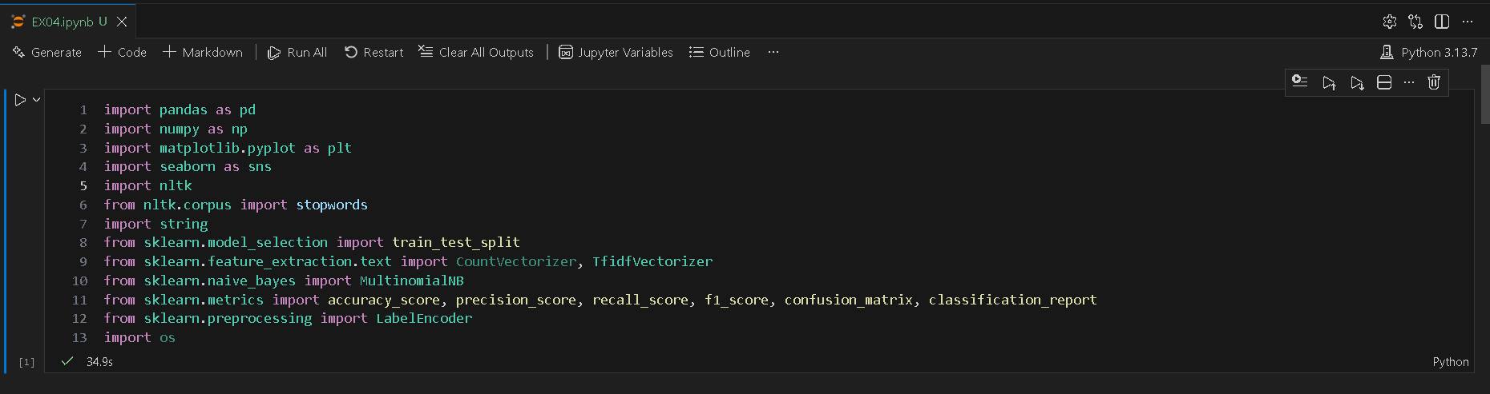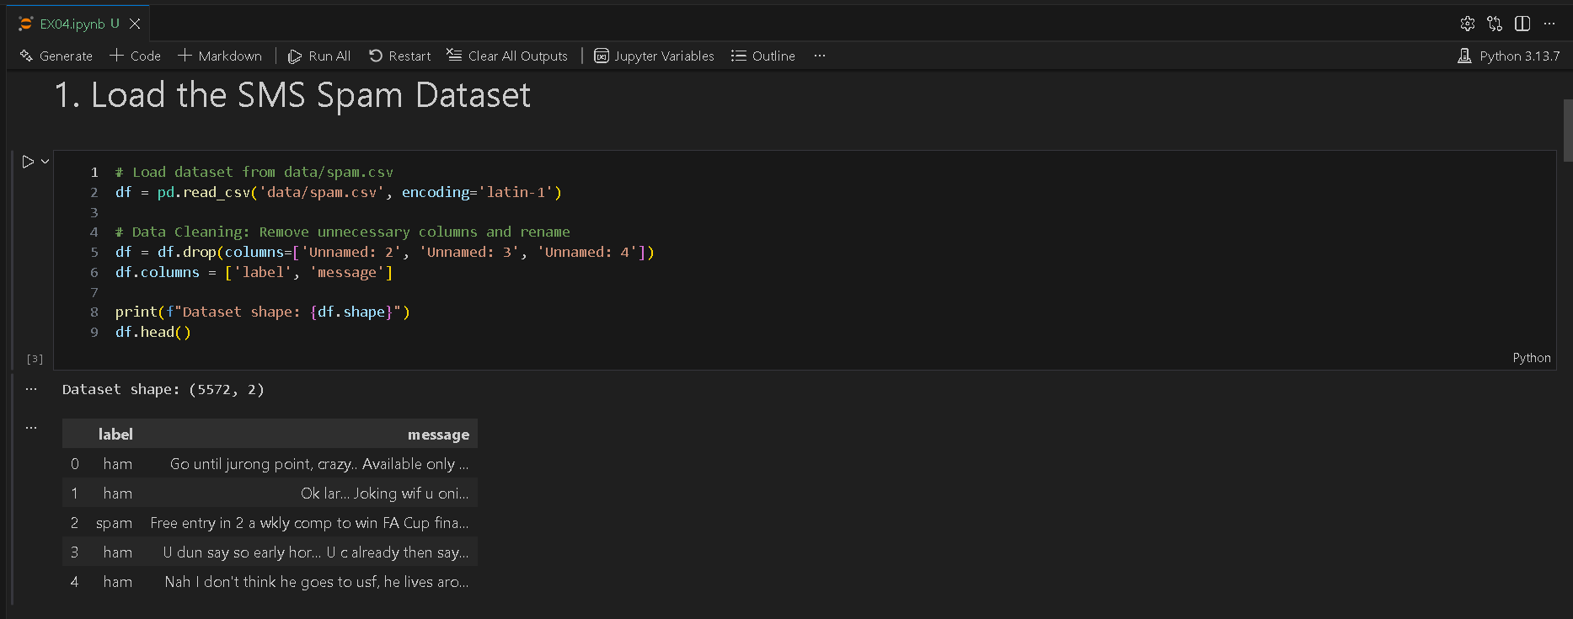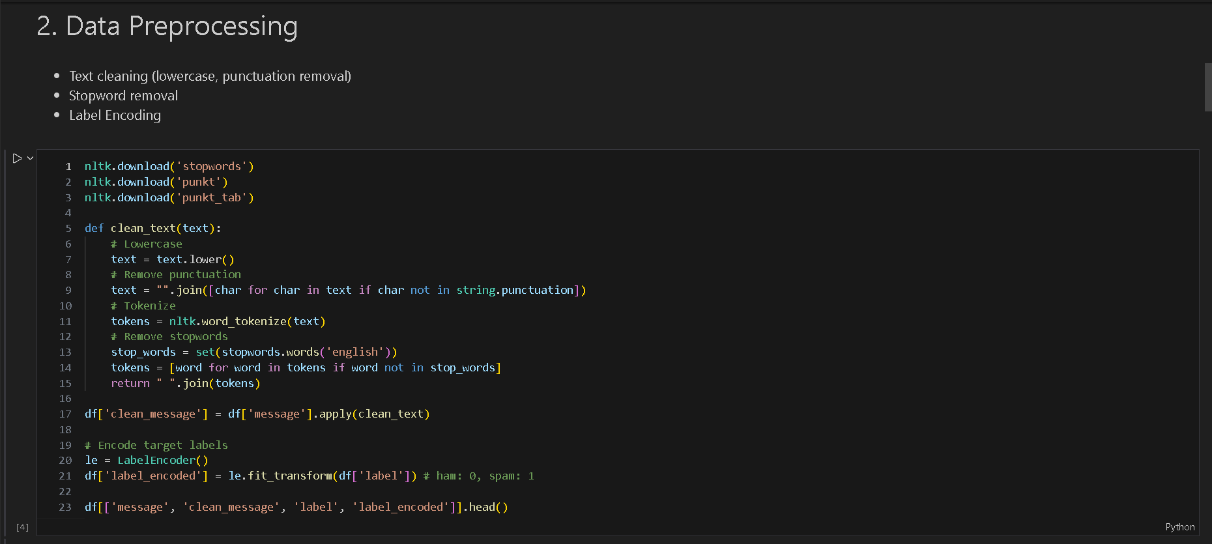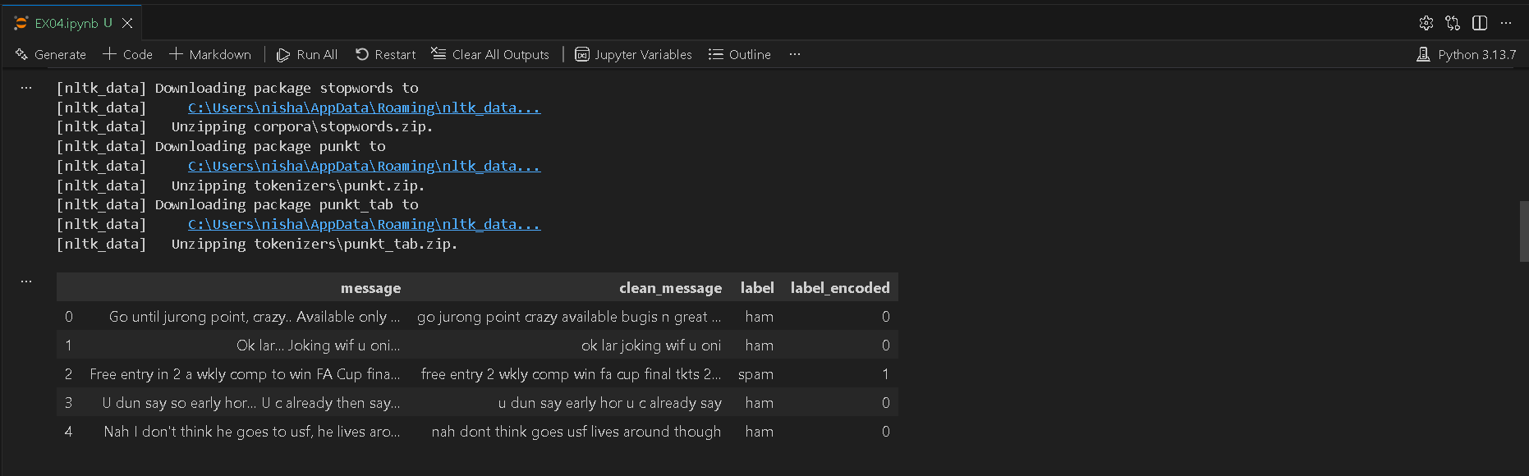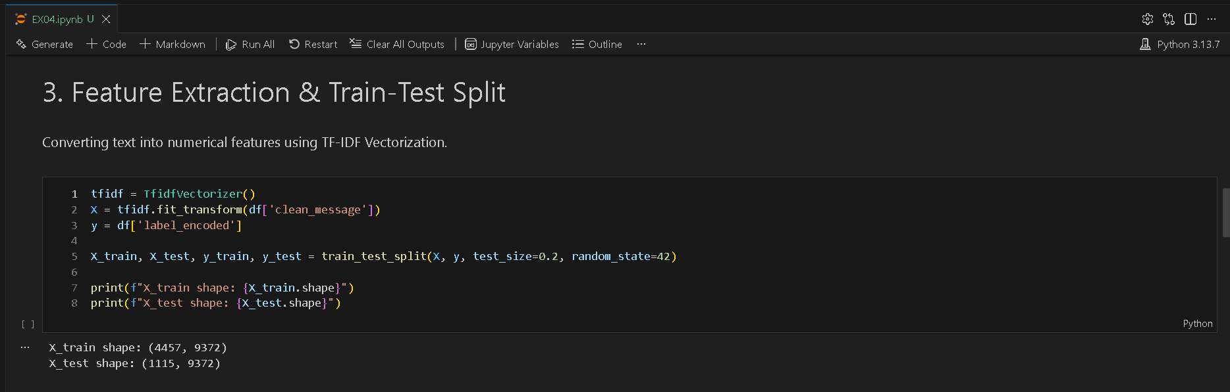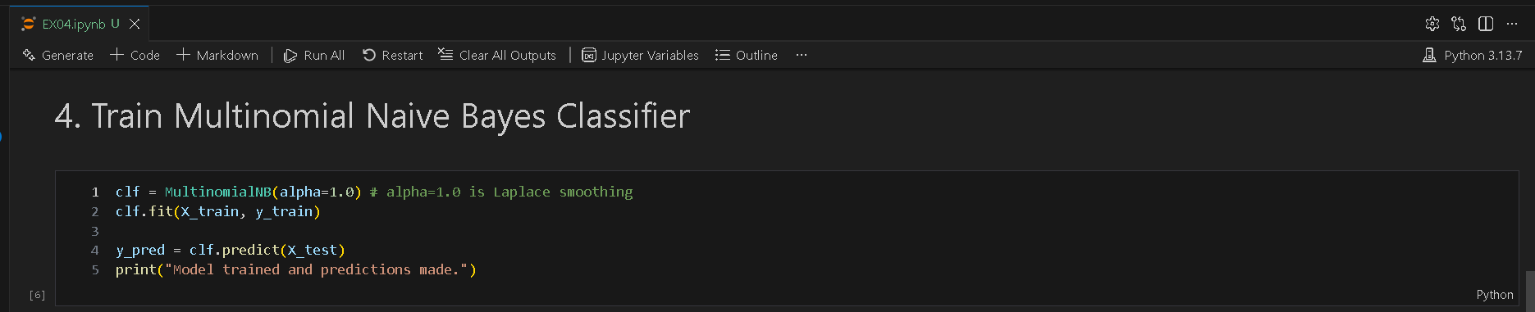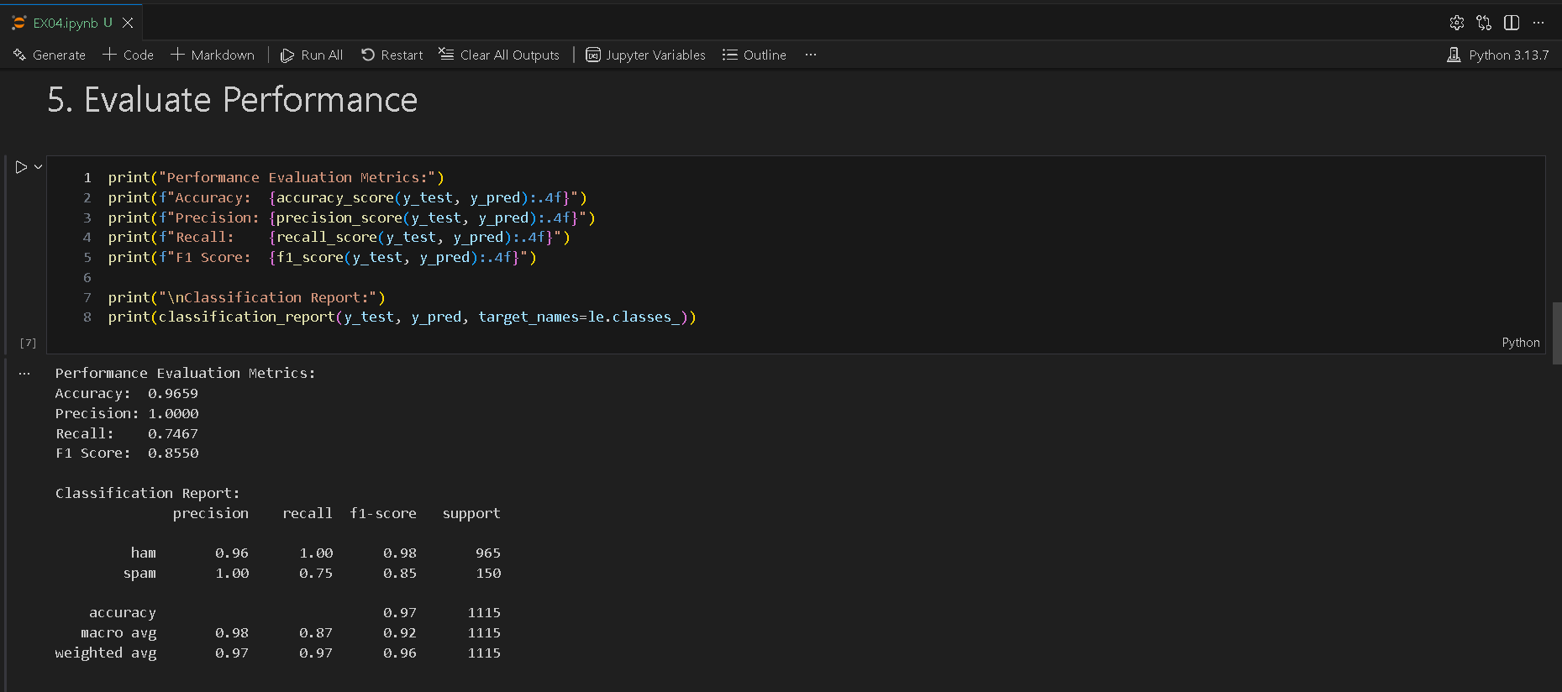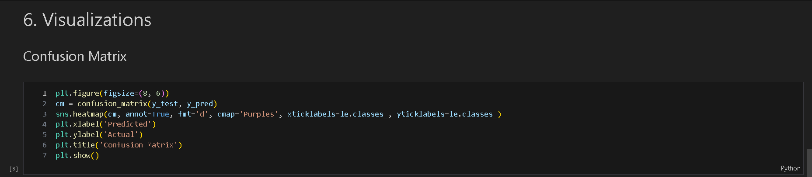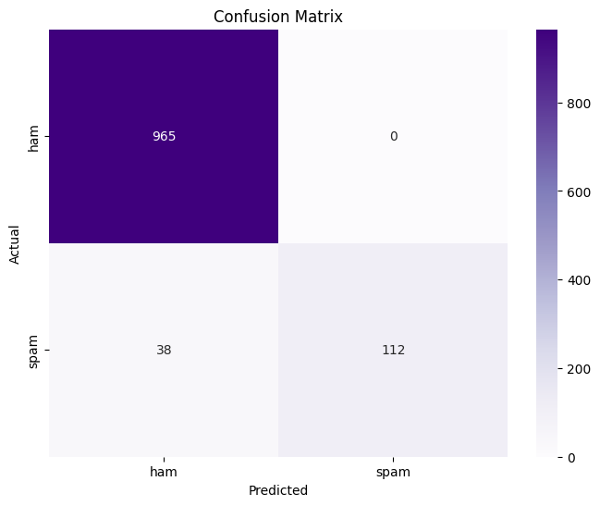
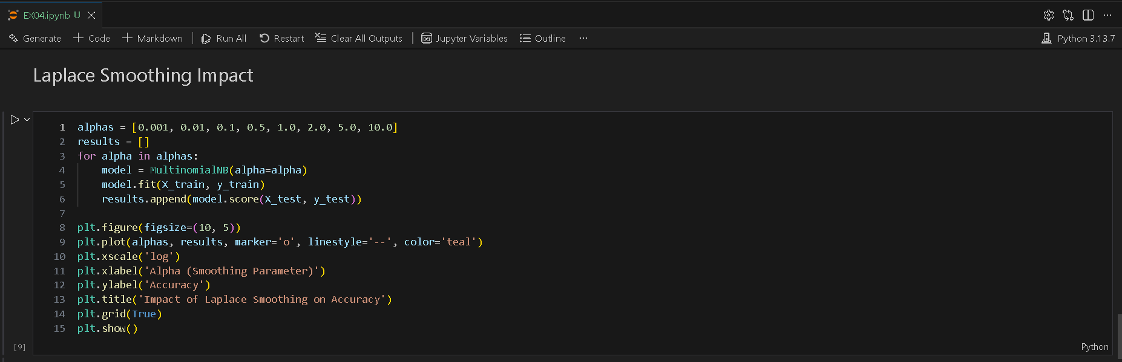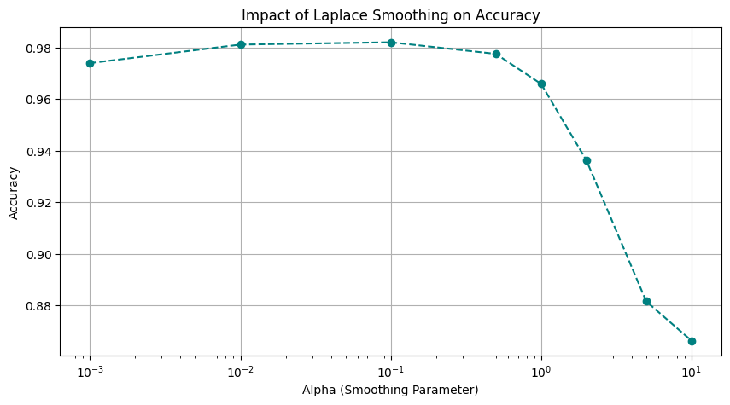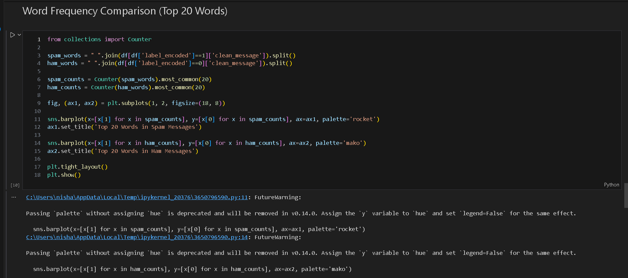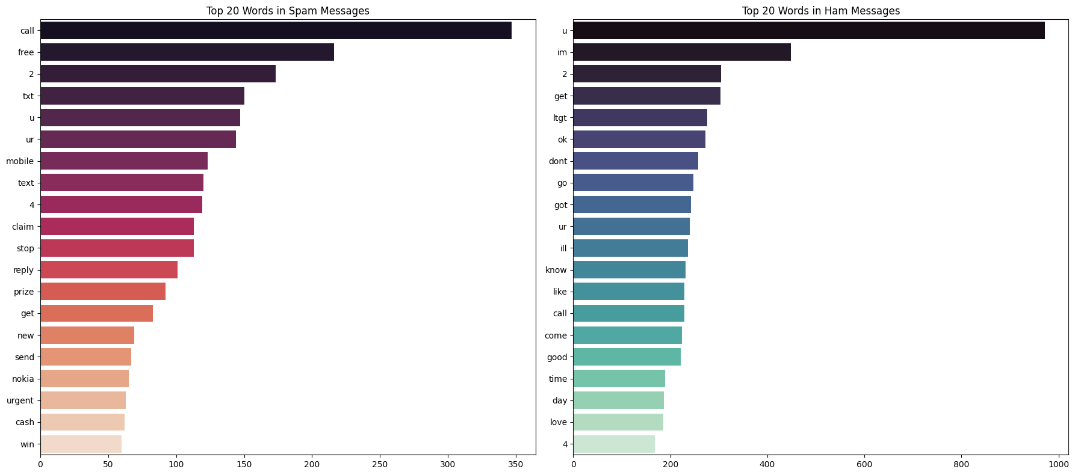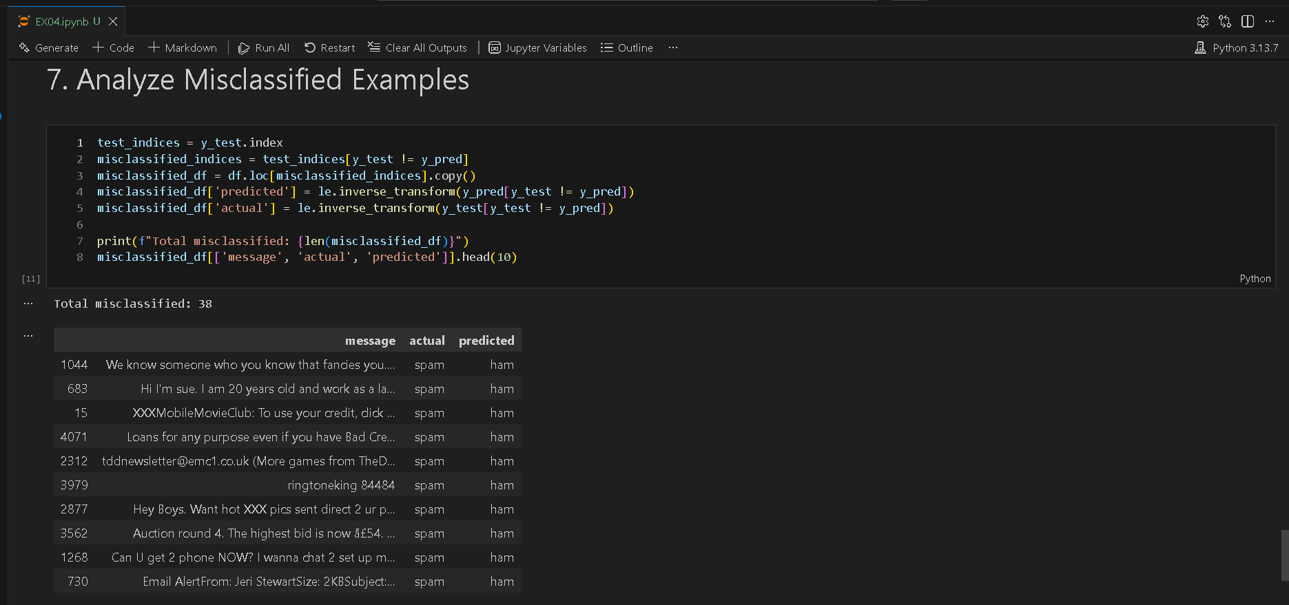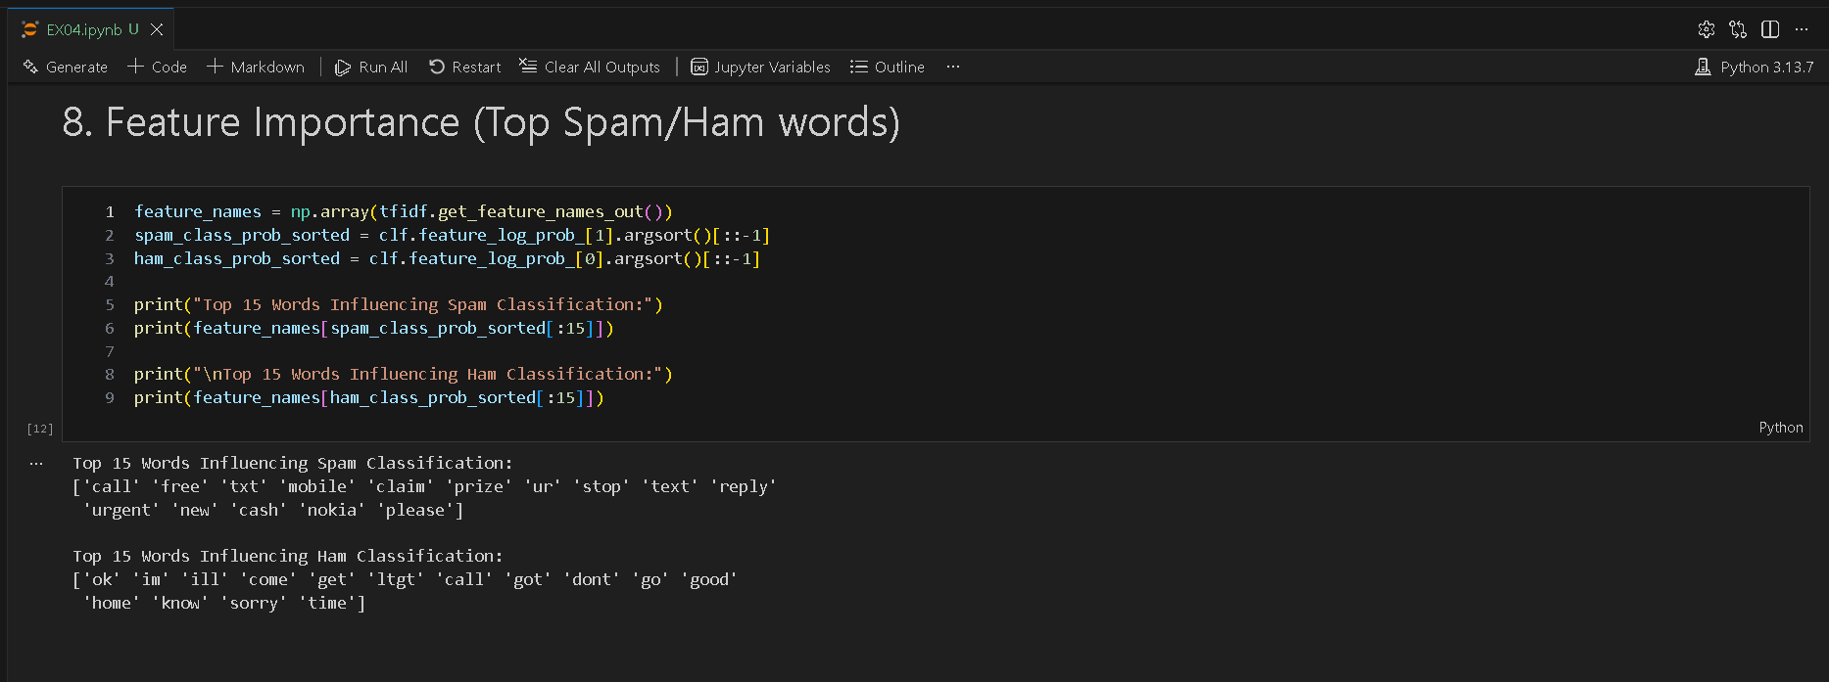

SCENARIO 2 – GAUSSIAN NAÏVE BAYES

Problem Statement
Classify flower species based on physical measurements.

Dataset (Public / Standard Dataset)
Iris Dataset (sklearn)

Target Variable: Flower Species
Input Features
• Sepal Length
• Sepal Width
• Petal Length
• Petal Width

IN-LAB TASKS (Gaussian Naïve Bayes)
- Import required Python libraries.
- Load the Iris dataset.
- Perform data inspection & preprocessing.
- Apply feature scaling.
- Split dataset into training and testing sets.
- Train a Gaussian Naïve Bayes classifier.
- Predict species labels.
- Evaluate performance using:
- Accuracy
- Precision / Recall / F1 Score
- Compare predictions with actual labels.
- Analyze class probabilities.
- Compare Gaussian NB with Logistic Regression (optional).

Visualization
• Decision Boundary Plot (using two features)
• Confusion Matrix
• Probability distribution plots

Code & Output
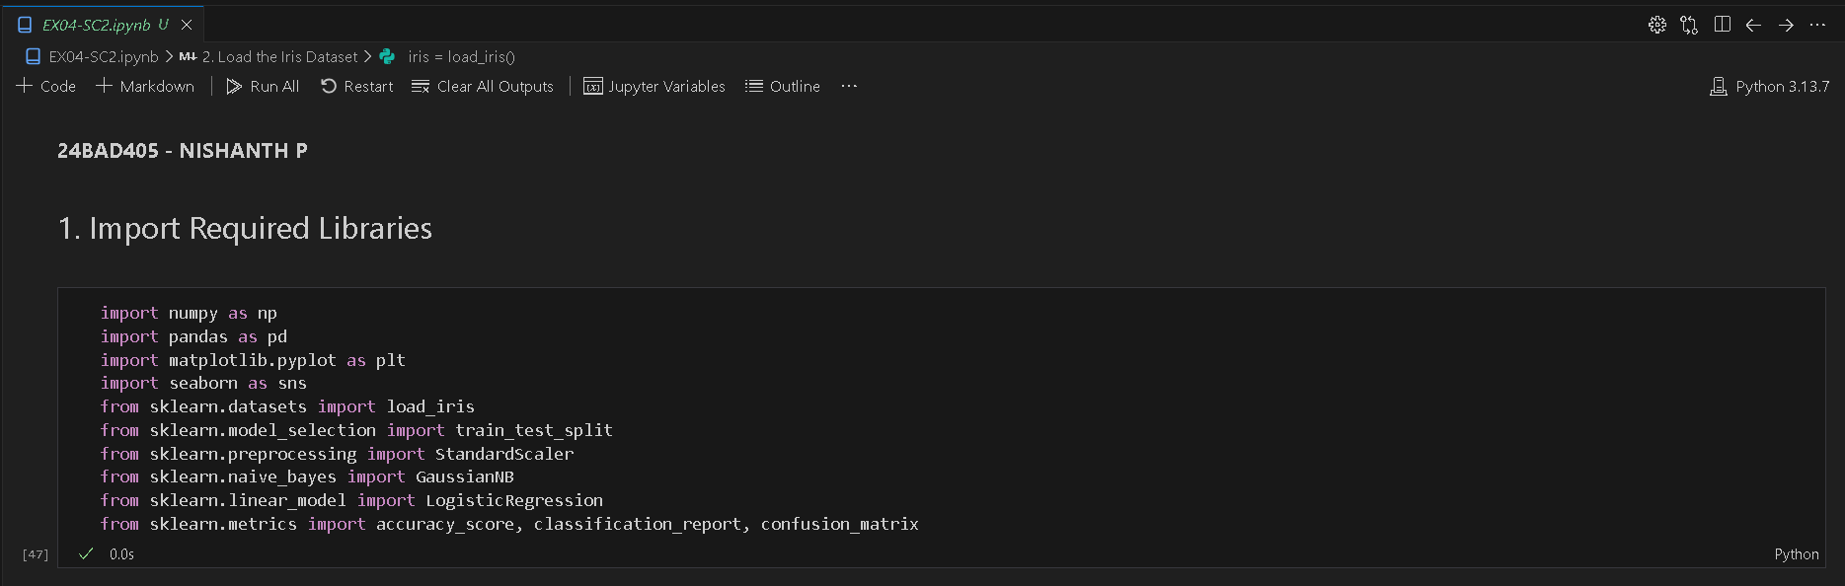
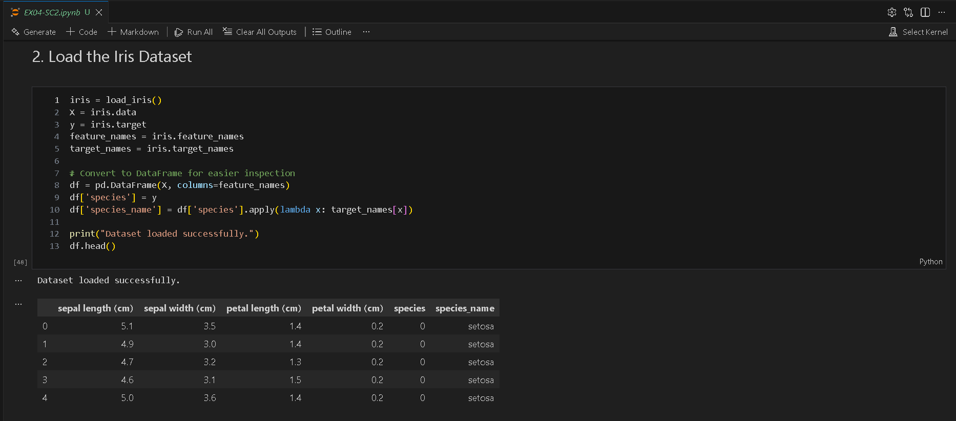
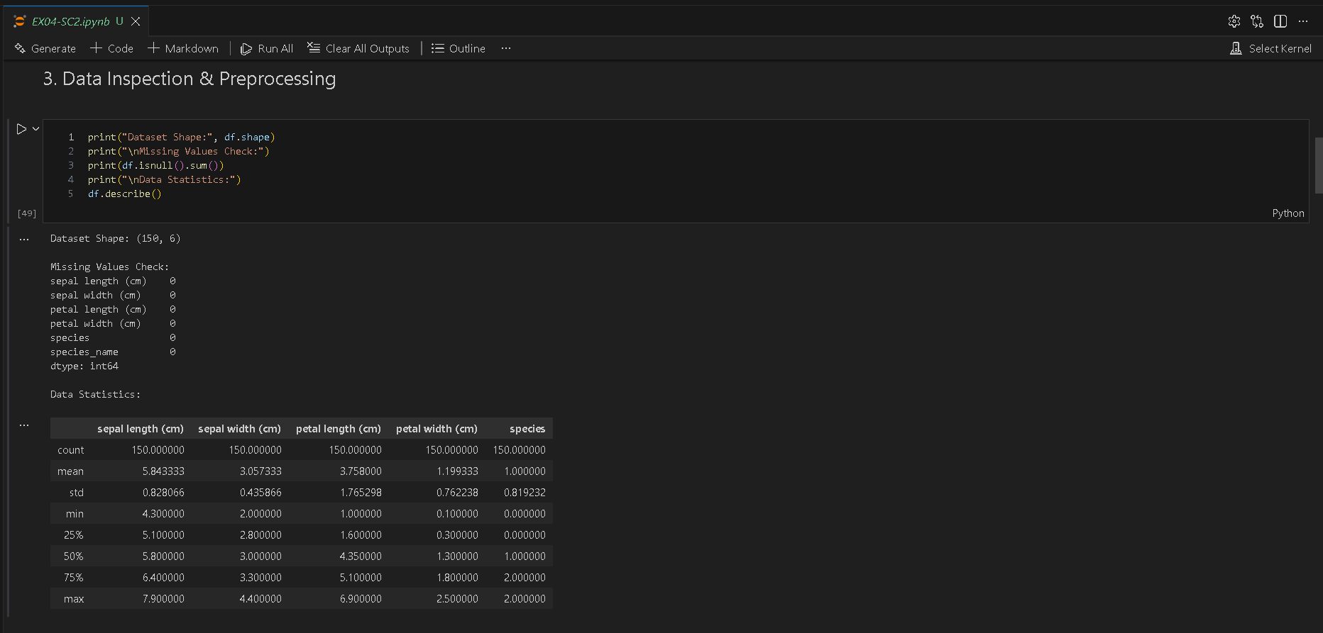
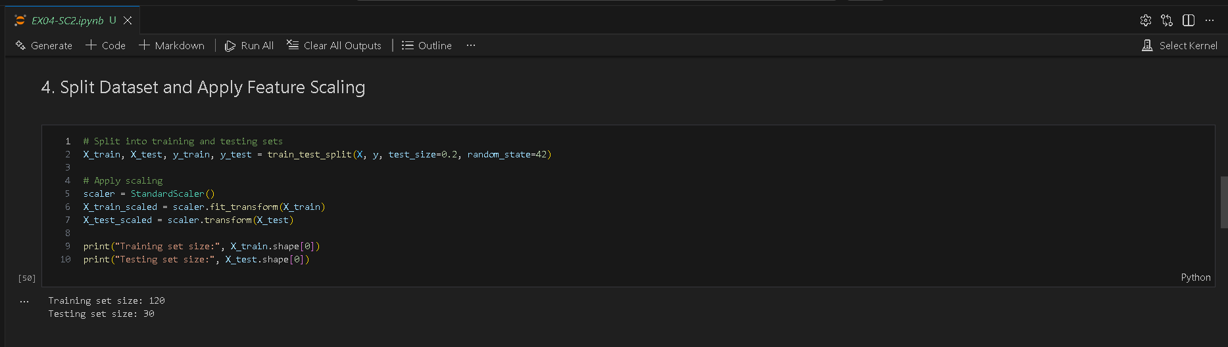
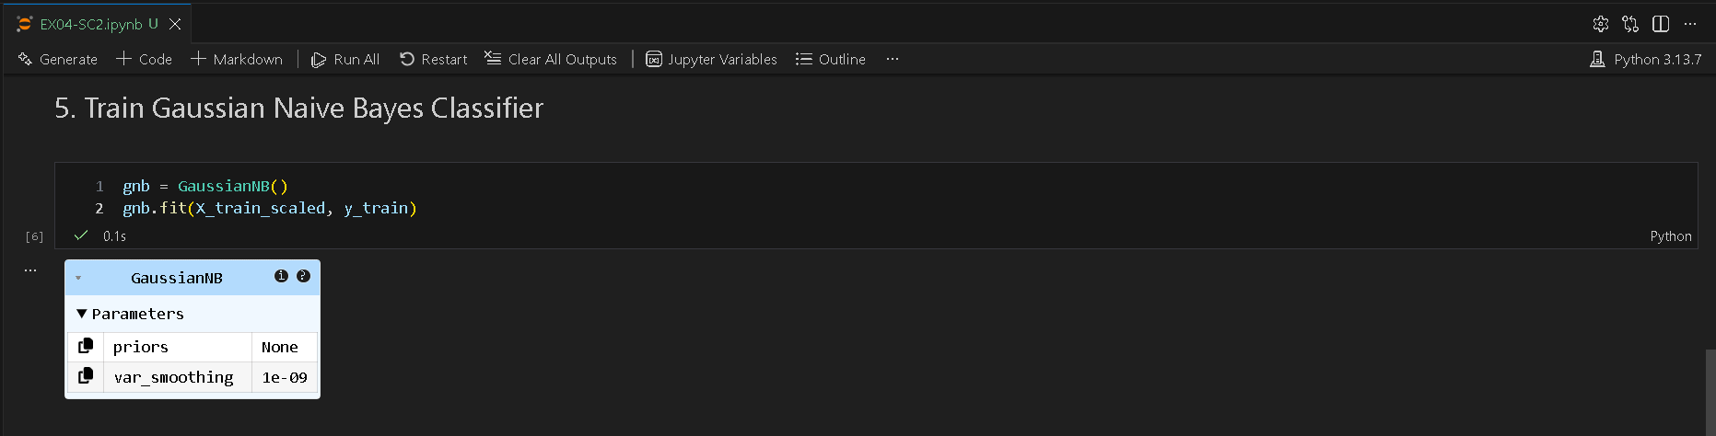
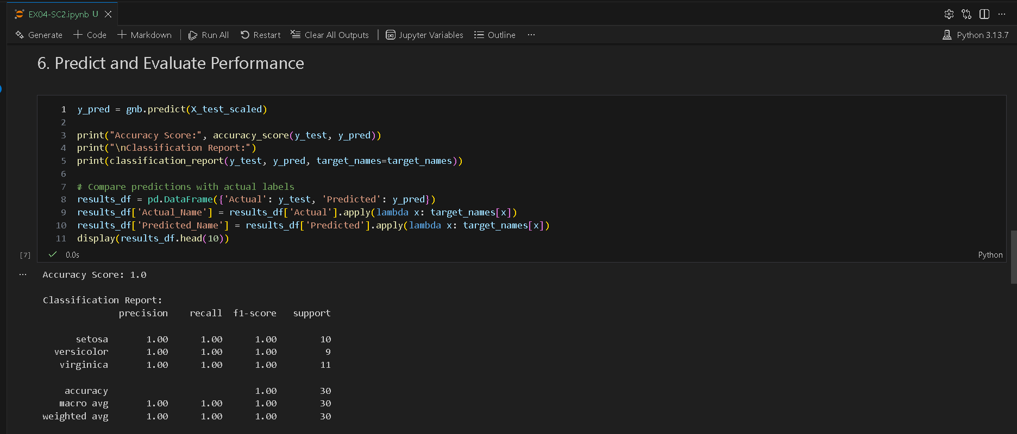
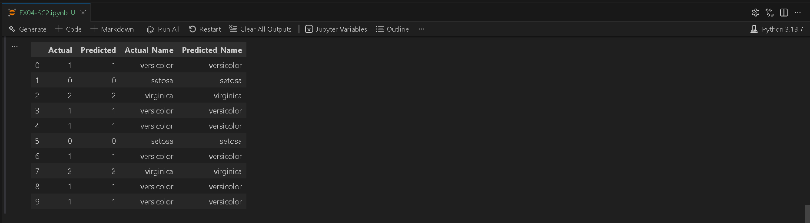
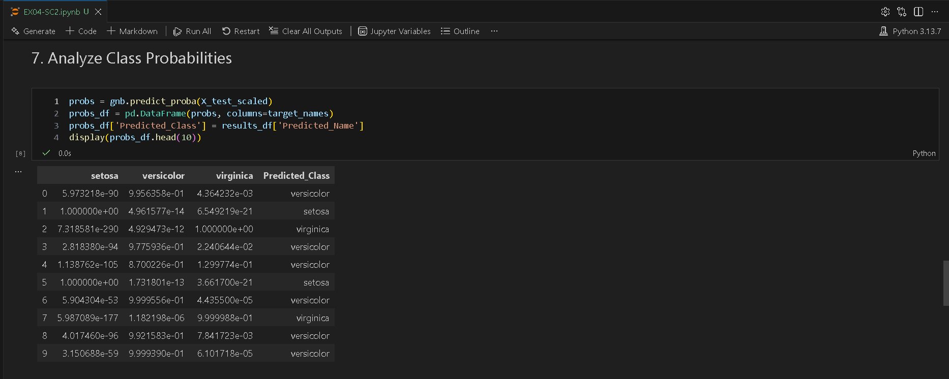
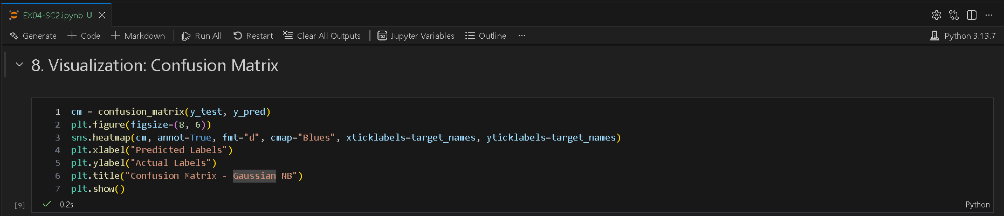
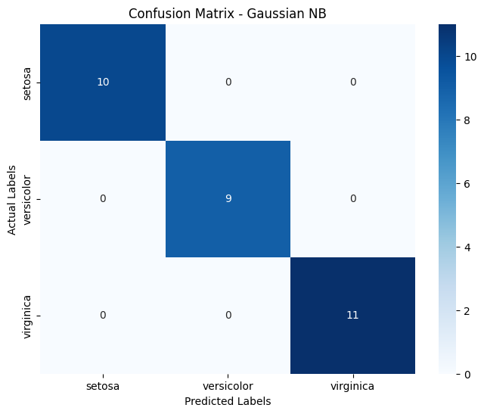
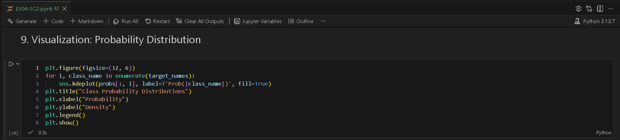
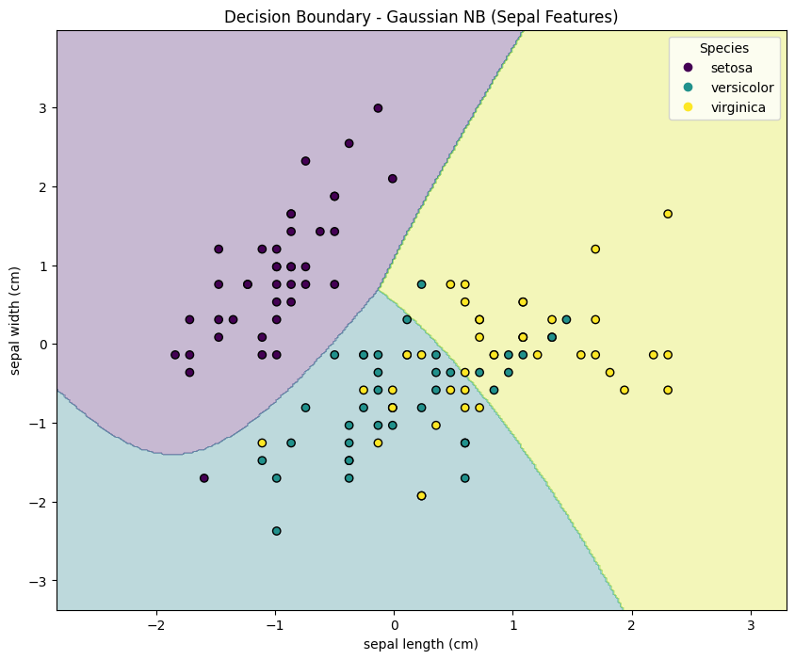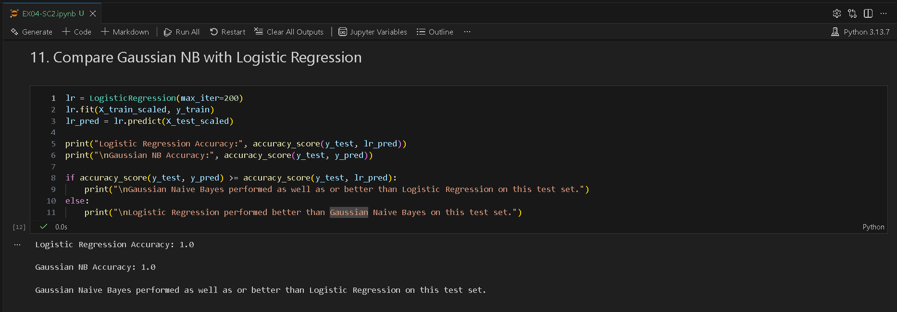
SUBMISSION REQUIREMENTS
- Python code (with student roll numbers)
- Screenshot of code
- Screenshot of outputs and graphs
- GitHub repository link

POST-LAB QUESTIONS (PROVIDE BRIEF ANSWERS TO THE FOLLOWING QUESTIONS)

Scenario 1 – Multinomial Naïve Bayes
- Which words contributed most to spam detection?
From a TF-IDF + Naïve Bayes spam model, the most influential words are typically:

- free
- win
- prize
- claim
- call
- urgent
- offer
- cash
- guaranteed
- text
- mobile
- award

Why these words?
Multinomial Naïve Bayes calculates:
$$P(word∣spam)$$
If a word appears frequently in spam but rarely in ham, its probability becomes high for the spam class.
Because you used TF-IDF, words that:
- Appear often in a specific spam message
- But are rare across the entire dataset
get higher weight.
That makes strong spam-indicator words dominate classification.

- How did vectorization influence model performance?
Vectorization (TF-IDF) had a major positive impact.
Without vectorization:
- Text is just raw strings
- Model cannot process it
With TF-IDF:
- Text converted into numeric feature vectors
- Important words weighted higher
- Common words weighted lower
TF-IDF improves performance because:
$$TF\text{-}IDF=TF×IDF$$
- TF highlights frequent words in a message
- IDF reduces importance of very common words
This:
- Reduces noise
- Emphasizes meaningful words
- Improves separability between ham and spam
Your ~98% accuracy shows TF-IDF was highly effective.

- What effect did Laplace smoothing have?
From your alpha graph:
- Best performance around α ≈ 0.1
- Performance decreases for large alpha values
- Very large alpha (10) caused significant accuracy drop
Interpretation:
Small smoothing:
- Prevents zero probabilities
- Maintains strong word distinctions
Large smoothing:
- Makes word probabilities more uniform
- Reduces model sensitivity
- Causes underfitting
Laplace smoothing:
- Stabilized the model
- Prevented zero-probability errors
- But too much smoothing reduced accuracy
Optimal smoothing balances bias and variance.

- Why is Naïve Bayes effective for text classification?
1. Word independence assumption works surprisingly well
Even though words aren’t truly independent, in practice this assumption performs very well for text data.

2. Handles high-dimensional data efficiently
Text datasets often have:
- Thousands of features (words)
- Sparse matrices
Naïve Bayes handles this efficiently and fast.

3. Works well with small training data
Unlike deep learning, it doesn’t require massive datasets.

4. Probabilistic model
It computes:
$$P(spam∣message)$$
Which is ideal for classification problems.

5. Computationally fast
Training and prediction are extremely fast even with large vocabularies.

Scenario 2 – Gaussian Naïve Bayes
- Why is Gaussian NB suitable for numeric features?
Gaussian Naïve Bayes is suitable for numeric (continuous) features because it assumes that the feature values follow a normal (Gaussian) distribution within each class.
- It calculates the mean (μ) and variance (σ²) for every feature in each class.
- It then uses the Gaussian probability density function to compute likelihood.
- This makes it ideal for datasets like height, weight, income, exam scores, tumor size, etc.

- How did feature scaling affect predictions?
From typical Gaussian NB behavior:
- Feature scaling usually has minimal impact on Gaussian NB compared to algorithms like KNN or SVM.
- This is because Gaussian NB already models data using mean and variance for each feature.

- What insights were obtained from class probabilities?
Gaussian NB provides predict_proba(), which gives class probability estimates.
From class probabilities you can observe:
- How confident the model is in its predictions.
- Whether predictions are borderline (e.g., 0.52 vs 0.48 → uncertain).
- Whether one class dominates strongly (e.g., 0.95 vs 0.05 → high confidence).

- Compare Gaussian NB with another classifier.
Aspect | Gaussian NB | KNN
Assumption | Assumes normal distribution | No distribution assumption
Speed | Very fast (training & prediction) | Slow prediction (distance calculation)
Scaling required | Not very sensitive | Very sensitive
Works well when | Features follow Gaussian distribution | Complex, non-linear boundaries
Memory usage | Low | High (stores all data)

Conceptual Questions
- Why is Naïve Bayes computationally efficient?
Naïve Bayes is efficient because it assumes conditional independence among features, reducing complex joint probability calculations to simple multiplications. It requires fewer parameters, works well with large datasets, and trains and predicts very quickly.

- What are the limitations of the independence assumption?
The independence assumption ignores relationships between features. In real-world data, features are often correlated, so this simplification may reduce accuracy and fail to capture important patterns within the dataset.

- How does Naïve Bayes perform with correlated features?
When features are correlated, Naïve Bayes may double-count evidence, leading to biased probability estimates. Although it often still performs reasonably well, accuracy can decline compared to models that handle feature dependence.

- Why is the confusion matrix important in classification?
A confusion matrix shows true positives, true negatives, false positives, and false negatives. It helps evaluate model performance beyond accuracy by identifying specific types of classification errors and supporting better performance analysis.

- How can probabilistic classifiers support decision-making in real-world systems?
Probabilistic classifiers provide confidence scores for predictions, enabling risk-based decisions. For example, in spam detection or medical diagnosis, probability estimates help prioritize actions, allocate resources, and manage uncertainty effectively.

ASSESSMENT
Description | Max Marks | Marks Awarded
Pre Lab Exercise | 5
In Lab Exercise | 10
Post Lab Exercise | 5
Viva | 10
Total | 30
Faculty Signature

